

**SCHOOL BUILDING PLANNING. MAIN TYPES OF SYSTEMS (PLANS) OF SCHOOL BUILDINGS**

**ABSTRACT**

How to Design School Buildings? Student(s), their number and age have the   
greatest impact on the school buildings;

• To plan a school well, it must first be clear which age groups of students it will be for;

• How many students will be there in each age group;

• How many classes in each grade will be in the building.

Following the study of children of various age groups, looking at the specifics of emotional development and various physical characteristics, it   
becomes clear to a large extent what is necessary to make them feel good in   
the school building.

The parameters of the individual rooms and buildings for educational   
activity are also determined on the basis of the applicable rules for town   
planning, the regulations for designing buildings and facilities, and the   
standards related to school buildings, hygiene standards and fire construction   
and technical requirements.

The complex study of all elements of the building, their interrelations, as   
well as the number and age of the students, in the context of the urban   
planning parameters and the requirements of each individual employer,   
determine the area and scale of design of the school buildings. Taking into   
account also the recent studies and trends for the good functioning of this   
type of buildings, a complex composition of elements, parameters and   
conditions may be obtained.

Following the study of children of various age groups, looking at the specifics of emotional development and various physical characteristics, it becomes clear to a large extent what is necessary to make them feel good in the school building. When examining the individual elements of the environment, one should bear in mind that each child influences the environment not separately, but as a whole, and in this case it is a group of children, i.e. a class in which there are 25-30 different students with similar perceptions and sensations. So, if we take 30 children and put them in a classroom what will we get? Each child gives off heat, greatly hinders the penetration of light, creates noise and absorbs the sound. A cold classroom becomes warm when filled with energetic children; a naturally illuminated empty room may lose its illumination after the children take up their seats. In an empty room, it may be quiet but what happens if there are 30 enthusiastic and noisy children inside?

Now we may draw a parallel with our present and the most common classrooms. They are of the same size and appearance. Dimensions 7.5 m per 4.5-5 m for 30 students, windows on one wall only, arranged along the entire long wall, a blackboard in the middle of the short wall, and desks or

tables arranged in three rows. All students by the windows are exposed to the strong sun; they are sitting in the warmest and the brightest end of the room, while the light does not reach the other end of the room. The same effect is observed in the winter when the heating is switched on. The children sitting near the radiators are warm and heat does not reach the other end of the room. The same refers also to the effect of environmental noise. Naturally, the loudest place is by the windows. Classrooms thus arranged are an obstacle to the smooth running of the learning process, making it a monotonous, routine process in which children are compelled to participate without desire. On the other hand, this environment hinders children’s physical health and well-being.

Several conclusions may be drawn with regard to the good design of the school building:

**First conclusion:** *The number of students is not a constant amount, it changes.* The school

must be so designed as to allow for its individual premises or parts to be effectively modified without disturbing the beauty of the building.

**Second conclusion:** *In each subject, such as math, Bulgarian, literature, etc., there will always be changes in teaching techniques.* For this reason, classrooms, laboratories and offices should be designed to economically and effectively adapt to these changes.

**Third conclusion:** *Students will spend a lot of time in the premises (over one hour a day).* Therefore, all rooms should be designed to help achieve the objectives of the educational program, meanwhile being as comfortable and cozy as possible to make children feel comfortable throughout the hours spent in the building.

**Fourth conclusion:** *The well-balanced, effective educational program emphasizes on communication between the STUDENTS in the classroom, as well as communication between the TEACHER and STUDENT.* For this reason, classrooms should be designed to allow for flexibility in the order, which implies good discussion, good audibility and good visual connection.

**Fifth conclusion:** *The school should be a real social center for children, i.e. students of all age groups.* Therefore, the school building should be planned and equipped so as to allow the students take it as the most desired place to study, work and play.

**Sixth conclusion:** *Find the right place for the building to facilitate the social life of a community, neighborhood, or area.* This is mainly related to easy communication, transportation, proximity to other centers for the children’s needs and remoteness from unfavorable neighborhoods and areas, respectively.

These conclusions are summarized into one main conclusion: all elements of the building are interrelated and require good planning and a well-functioning educational process.

After making the above conclusions, the elements of the environment that have the greatest impact on the child may be identified. These elements influence not only the emotional sensation but also the physiological and anatomical characteristics.

**- area, scale and planning of spaces and buildings** – volume of premises, size of classrooms and recreational areas. Modern trends for planning school buildings with zoning and separating the age groups of students. Types of school buildings according to the method of planning.

**- ventilation** – the possibility of penetration of fresh air from the outside, natural and artificial ventilation.

**- illumination and transparency** – natural and artificial light, determination of window parameters and dimensions. Search for maximum transparency of the embracing elements and the possibility of correcting the luminance entering through them.

**- acoustics and noise** – noise level. Parameters of noise coming from the embracing areas and the noise generated inside the building. Ways to prevent noise from entering the learning areas.

- **color solution** – the color of the interior of the embracing elements /walls, ceilings and flooring/ and individual elements of the equipment. Color palette, psychology of colors and the effects of different color solutions. Combinatory. Techniques in the use of different colors.

- **materials/texture/enclosures.** Types of materials and their participation in the overall emotional and physical perception.

- **furniture from the interior. Dimensions, scales and materials for their production –** link between the physiology of students in different age groups and dimensions of the interior space elements. Ergonomics of furniture and training devices.

These are the elements of the environment, and what is the task of the designers? The objective is to place these children in an environment where there will be the least possible adverse impact on them – it will give them comfort.

And what is the environment, what is the interior? What are the elements of the building based on which the next study will be carried out?

Elements of the school building:

• Main foyer

• Corridors – considered as a separate element, as in modern school they perform also other

functions, in addition to the main one for movement and connection between the premises – they have a wider social character.

• Training rooms – classrooms, rooms for special purpose /laboratories, music rooms, fine art rooms, crafts rooms and computer rooms/.

• Administration and teachers’ room

• Sports area

• Canteen and kitchen

• Information premises – library, media library and self-study premises

All these, based on the new research and different school planning concepts, give a new idea

of the learning process in a certain, good and comfortable environment and shows the main directions in the design of the interior spaces.

**1. Types of school buildings. Corridor and non-corridor system.**   
*“Architecture – it is the art of organizing space” –* **Auguste Perret**  
*“The new reality of the completed building is interior – the inner space, and the walls and*

*roof only serve to enclose it” –* **Frank Lloyd Wright**

*“The central problem of architecture is the space that is created to keep our spirit healthy. It*

*is important for me to develop space in the service of man –* **Justus Dahinden**

*“The historic mission of architects is always to set all kinds of object shapes within human*

*environment in such an organic state as to connect them in a harmonious living space” –* **Walter Gropius**  
Interior embraces the inner spaces in architecture, that is the element in the lack of which it loses its

meaning. This is evidenced not only by the opinions of some of the great architects, but also by the fact that there may be no architecture without inner spaces, whereas the opposite exists. For example, underground subway stations, rock temples, underground pedestrian zones and shopping centers, etc.

When looking for the elements of the interior and the principles for establishing a good interior space, it is clear that we should start with the overall design of the building, with all the factors that influence it. Internal spaces and embracing elements are the architecture itself. But the embracing elements are just a transition between the interior space and the environment. They are subordinate or rather a consequence of the internal structure and meanwhile, part of the environment.

Architectural creativity is an indivisible process. If a perfect internal structure is closed by a badly designed shell /facades and roof/ that does not take into account the composition of the interior or does not conform to the function or the environment, the result would be disappointing.

**Conclusion: The real architect thinks globally and looks for a perfect interior with a beautiful exterior.**

In order to define the principles and elements of the interior of school buildings, the various buildings should be defined first depending on their functional outline and planning approach.

The architecture of school and educational process are closely related and united around the “student” unit. In architecture, the greatest danger lies in over-emphasizing the environmental factors that affect the physical and emotional comfort of the student at the expense of paying attention to the educational factor. That is, there is a danger of forgetting that the internal spaces are shaped and processed to be comfortable for the student. In primary education, there is a tendency towards establishing a family-friendly environment and search for a close link between the teacher and his/her young pupils, which may however affect the educational control and discipline. Sometimes, such a link may encourage lenient maternal relationships that do not meet the student’s needs, especially with older students. It is therefore necessary to strike a balance between architectural planning schemes, the individual elements of the interior space and the requirements of pedagogues and psychologists.

Designers and teachers are thus interconnected in the construction of schools that place emphasis on the requirements of educational programs.

Throughout the history of pedagogy there were innovators whose ideas were either misunderstood or ahead of time. Their ambition was to change the training and the conditions in which it was conducted. From the 14th century the emergence of new ideas in education has become more prominent. New

pedagogues and innovators were **Vittorino da Feltre**, 1378-1444, **Michel de Montaigne**, 1533-1592, **Jan Amos Komenský**, 1592-1670, **John Locke**, 1632-1704, Jean**-Jacques Rousseau**, 1712-1773, **Johann Heinrich Pestalozzi**, 1746-1827, **Johann Friedrich Herbart**, 1776-1841, etc.

Not so long ago, schools were almost exclusively centralized. In the 19th century, the student was widely regarded as an “element” which function was to become an adult as soon as possible. Primary schools worked to promote literacy and spread basic knowledge. The activity of the secondary school was mostly to prepare the students for university, despite the fact that only a small number of students will go to university. Communication was in one direction only, i.e. from teacher to student.

The architecture of school building greatly reflected this concept. Since not much attention was paid to the human rights and needs of children, schools were almost equally unpleasant and depressing. Buildings impressed and imposed respect and veneration due to their big dimensions. Their planning was not less formal than the learning process. Their exterior was meant to respond to pride, ambition or sentimentality, and to impose respect. Classrooms were occupied by students “conveniently” grouped in solid lines, and a teacher who was elevated in front of them onto a platform from which he gave all knowledge, made judgments, required order and imposed control. There was no thought of the interior and the comfort of environment. The colors in the rooms were monotonous, whites predominated. The green color was often used, and the blackboard was the most dominant item. It was relied on natural materials, i.e. stone and wood. The rooms were dark, and the windows were small.

In this period, the values were different. The order and discipline were essential, the instructions were strictly observed, the teacher’s authority was great and he/she was listened to without any right of contradiction and personal opinion. There were some very strong concepts, such as patriotism, humbleness, obedience, patience, hard work, discipline and self-discipline.

After the first half of the 20th century, with the change of the emtire concept of education, the approach to planning school buildings has changed. The student, no matter what age group, is seen as a true human being with human rights and needs that should be respected. The primary school is meant to help the child become social and to encourage his/her individual talents, as well as to make him/her literate and provide him/her with basic knowledge. The activity of the secondary school is intended to support the preparation of the child for good realization in life, as well as to prepare him/her for the university if he/she wishes so. Education is relatively democratic. Communication takes place between teacher and student, and between student and teacher, i.e. two-way.

The founders of the new school are **John Dewey**, 1859-1952, **Maria Montessori**, 1870-1952, **Rudolf Joseph Lorenz Steiner** 1861-1925.

School architecture attempts at reflecting this concept. As the student is seen as a person with rights and needs, schools strive to become more comfortable, more cozy and welcoming. In appearance, they tend to respond to the student’s emotional needs. Classrooms are designed and equipped for different learning situations. In addition, new schools are flexible, responding to the ever- changing nature of the theory and practice of the educational process.

One of the brightest representatives of the reform of the school system, which would unconditionally lead to a change in school buildings, is **Sir Ken Robinson**, 1950. In one of his speeches, he defends the idea that for children to learn and express their talents and skills, they need a good environment.

*“So I think we have to change metaphors. We have to get out of what is now an industrial model of education, an industrial model that is based on linearity, compliance and grouping of people. We must move on to a model that is more based on the principles of agriculture.* ***We must admit that human blossom is not a mechanical process, it is an organic process. And you cannot predict the outcome of human development; all you can do is, as a farmer, create the conditions in which they will start to bloom.”***

*"It is necessary to understand perfectly the life of the students and the real processes through which they may be stimulated to study with desire. This can be done with teachers who are keen on their subject and with the gift of communicating with the students.* ***/Here I would add: a good environment in which processes may be carried out./*** *You must always rely on the strengths and ideas.*

*It isrelied on social skills, communication, imagination. Teachers teach subjects of interest to children, in classrooms turned into stages, workshops, and other different opportunities where people communicate and solve problems.”*

These summaries are intended to outline some of the more significant changes in the learning process that necessitate the respective changes in the architecture of buildings and hence, of course, of the interior spaces.

Since the middle of the 20th century, different criteria have been at the heart of planning and construction of school buildings. At the core of any design process is the need for a functionally correct zoning and a good connection between the elements of the building.

For the good functioning of the school it is necessary to start with the zoning of the individual parts of the building. For this purpose, it is necessary to define the basic parameters that influence the plan and the volume of the school building. In this case, there is a large number and different elements /areas/ that are functionally linked and used by a large number of students at different school age over a different period of time.

Main influencing parameters:

• Typical conditions – type and area of the property, location versus streets and main

approaches, location to the world directions;

• Requirement for the type of school – which age groups will be included, how many

students will be in each age group and how many classes in each grade;

• Regulatory framework and sanitary and hygienic requirements

Student(s), their number and age have the greatest impact on the school buildings;

• To plan a school well, it must first be clear which age groups of students it will be for;

• How many students will be there in each age group;

• How many classes in each grade will be in the building.

It is clear that students are at the heart of building planning. By determining their number, it is

easy to determine the number of classrooms, and knowing how many children will be there in each age group, an assessment of the zoning for the individual groups may be made. Thus, given the minimum parameters of individual rooms and the size required for each student, it is possible to get an idea of the area and volume of the school building, but this is not enough.

In the previous section, we determined the differences in the psychological and physiological aspects among children of different age groups. Their differences lead to the necessity of zoning them into separate parts of the school building. However, this is not a complete separation; it should be kept in mind that part of the premises in the building will be shared by all.

Depending on the individual elements of the building, they need to be grouped according to whether they are intended for a specific group of students or for the needs of everyone in the school. Elements of the school building were mentioned in the previous part of this dissertation, and now these will be considered as parts depending on how they are used:

• Main foyer

• Corridors

• Teaching rooms – classrooms for an individual age group

• Training rooms – rooms for special purpose /laboratories, music rooms, fine art rooms,

crafts rooms and computer rooms/

• Administration and teachers’ room

• Sports area

• Canteen and kitchen

• Information premises – library, media library and self-study premises

*\*In blue color are the premises for use by all students and teachers*

A large part of the building is for common use. It is possible to separate a small area for sports

and games for the youngest students near their sector, and also in the dining room it is necessary to separate an area for them, considering the need for smaller sized furniture to eat meals. Proper planning is related to the correct identification of the connections between the individual elements, their grouping in separate zones and the need to connect them in a way that corresponds to the educational process. We should not neglect the fact that the connections /corridors/ should not be too long on the one hand, given the need for rapid evacuation, and on the other hand, to reduce the time for the students to move from room to room during breaks. The youngest students still find it difficult to navigate in the environment, so the communications for them must be clear and concise, easy to remember the way to the room and the common areas.

**Conclusion.** Connections must be clear, concise and functional.

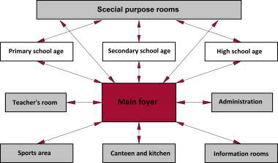

*Fig.1. Functional connection between the individual elements of the building*

The parameters of the individual rooms and buildings for educational activity are also

determined on the basis of the applicable rules for town planning, the regulations for designing buildings and facilities, and the standards related to school buildings, hygiene standards and fire construction and technical requirements.

The complex study of all elements of the building, their interrelations, as well as the number and age of the students, in the context of the urban planning parameters and the requirements of each individual employer, determine the area and scale of design of the school buildings. Taking into account also the recent studies and trends for the good functioning of this type of buildings, a complex composition of elements, parameters and conditions may be obtained.

Before you start designing this kind of building, you need to know that the dimensions and the area of the plot is of great importance. The chosen plot should meet the requirements not only in terms of size, but also in terms of its location, noise characteristics in the area, pollution and easy accessibility. It should be noted that as there are requirements for the dimensions and areas both of the individual premises in the building and the patio space. Outside the building there are areas necessary for outdoor sports, games and recreation, which are determined based on the number of students and are zoned depending on the age groups of students.

Of all these parameters and elements, several types of school buildings are defined according to their planning schemes. The common parts – foyers and corridors, and the location of the other elements of the building connected to them, are of prime importance.

In this connection, many authors have been working for the determination of school buildings and various typologies have been elaborated. One of the detailed research was performed by Stephen Clinton in “Primary and Secondary Schools”, published in 2001. Another study is by Alessandro Rigolón, who characterized the main types of school buildings in 2013. One of the best and most detailed research has been done by Arch. Prof. Ivan Sazdov, M.A. and Arch. Vesselina Grancharova, Senior Research Associate, M.A. in “Architecture of School Buildings”, 1989. The research has been used as the grounds of this dissertation and has been further developed with the determination of new planning solutions and good ideas for the individual buildings, land the addition of a few more subtypes.

In general, two basic types of systems /schemes/ of school buildings may be defines:

• corridor system;

• non-corridor system.

If we add different subtypes to these basic types of systems, this significantly enriches the

typology of school buildings and determines their variety. No matter what system we choose for the planning of the school building, the basic requirements for number, type and area of the individual premises and the functional connections between them are always preserved.

Most of the proposed types of building have been actually implemented, others are just a design option.

**1.1 Corridor system for planning school buildings**

The corridor system is characterized by a sequence of space and area deployment, with longer

interconnections between sectors and requiring a larger area of design plots.

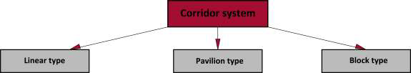

*Fig.2. Schematic of corridor system subtypes*

From the corridor system, the following subtypes of planning schemes may be defined: **linear**

**type, pavilion type and block type**. Several subtypes are also identified.

• **Linear type**

For this type of planning, the plot size for the building should be larger. In school buildings for

all groups of students (of different age) there my be no good separation or some autonomy. This is only possible if they are distributed on separate floors.

Due to the fact that the building has premises for common use (for all students in the age groups), this type of school is characterized by longer connections thereto.

This type of buildings has several subtypes:

• **open subtype**

- single-line – with one-sidedly located premises, with two-sidedly located premises, with Г-

shape to the two previous subtypes, with П-shape to the two previous subtypes, and combination of one-sidedly and two-sidedly located premises;

- multilinear type – with one-sidedly located premises, with two-sidedly located premises, and combination of one-sidedly and two-sidedly located premises.

• **closed subtype** – multilinear type – with one-sidedly located premises, with two-sidedly located premises, and combination of one-sidedly and two-sidedly located premises.

Table 1. Subtypes of the liner type.

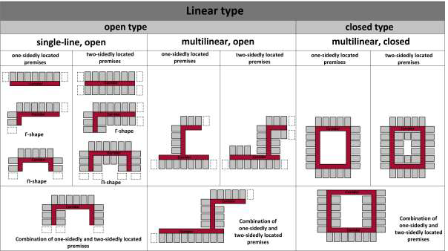

*- Corridor; - Classrooms*

In both systems /open and closed/, four subtypes of buildings for each type may be considered: **symmetrical – asymmetrical and one-story – multi-story**.

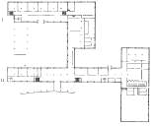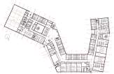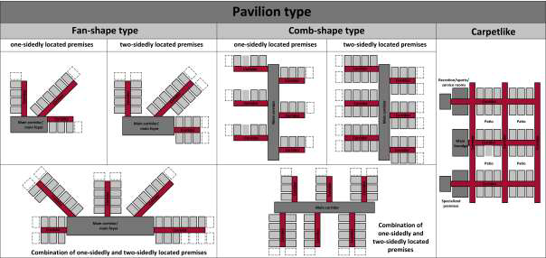

South Africa, 2012

Ratoath, 2007

Table 2. Examples of linear type of school buildings from 19-21 century.   
**Type of school**

**building**

|  |  |  |
| --- | --- | --- |
|  | **Buildings from 19-20 century** | **Buildings from the end of**  **20th and the beginning of**  **21th century** |
| **Open, one-line** | Baroda School, India, 1888 | Hout Bay International School, |
| **Open,**  **multilinear** | 60-class School in Toliati, the former USSR | Ratoath College, Jamestown, |
| **Closed,**  **multilinear** | Girls’ High School – Varna, Bulgaria, 1910 |  |

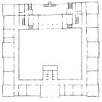

• **Pavilion type** of buildings creates a wide variety of fully landscaped to more orthogonal solutions. The natural adhesion of the building to the environment is typical. It also has several subtypes: fan-shaped, comb-shaped or “Fingers” type, carpetlike. Among them there are some varieties.

Table 3. Subtypes of pavilion type

*- Corridor; - Classrooms; - Main corridors and foyers*

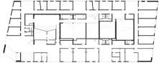

**Buildings from 19-20 century Buildings from the end of 20th and**   
**the beginning of 21th century**

**Fan-shape type** Primary School, Casablanca, Morocco,   
1954

Todd Vimmer High School, Washington, USA, 2003

• **Fan-shape type** – it is outlined by a main corridor or foyer, from which corridors with rooms attached thereto begin:

- with one-sidedly located premises;   
- with two-sidedly located premises;   
- combination of one-sidedly and two-sidedly located premises.

It is possible that each building from the fan-shape subtypes is executed symmetrically horizontally or vertically, or centrally symmetrically.

• **Comb-shape type /”Fingers” type/ –** this type is characterized by a main corridor or foyer, from which corridors with rooms attached thereto begin:

- with one-sidedly located premises;   
- with two-sidedly located premises;   
- a combination of “sleeves” with with one-sidedly or two-sidedly located premises.

• **Carpetlike type** – this is a structure with patios in front of the premises  
Table 4. Examples of pavilion-type school buildings from 19-21 century

|  |  |  |
| --- | --- | --- |
| **Type of school**  **building** |  |  |
|  |  |  |
| **Comb-shape type /”Fingers” type/** | Jorgensburg School in Roskilde, Denmark, 1958 | Lawrence High School, Lawrence, Massachusetts, USA, 2006 |
| **Carpetlike type** | Stavensholt School, Denmark, 1971 | Art School, Latvia, 2013 |

• **Block type**

The following subtypes are defined to this type of school buildings: with a covered atrium

space – vestibule, with a covered atrium space – patio. In his thesis "VERTICAL COMMUNICATION IN THE INTERIOR SPACE" Dr. Arch. Evgeni Rafailov writes:

"Atmospheric and galley spaces are the soul of space-to-space buildings, and their search for architectural solutions occurs in the case of buildings of particular social importance (museums, theaters, operas, administrative buildings, banks, schools, universities, mixed multifunctional buildings, residential buildings, etc.) "

These are subdivided to the following subtype:

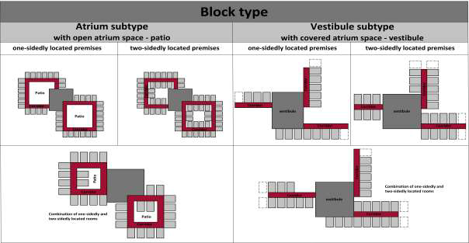

**Buildings from 19-20 century Buildings from the end of 20th and the**   
**beginning of 21th century**

**With open**   
**atrium space – patio**

Oberhabing State High School near Munich, 1978

Public School, Chicago, USA 2005

2007

• **with open atrium space –** **patio** – this solution determines the need for concentration of the common spaces expressed by a square (or close to the square/spatial center):

- with one-sidedly located premises – with this subtype the corridors face the patio. It is possible to design them as open galleries, arches and colonnades.

- with two-sidedly located premises – there are rooms facing the patio.

- a combination of one-sidedly and two-sidedly located premises around the communication center.

• **with closed atrium space –** **vestibule** – there are corridor bodies located around a central

wide-area block, which core is a multifunctional vestibule space:

- with one-sidedly located premises

- with two-sidedly located premises

- a combination of one-sidedly and two-sidedly located premises around the communication center.   
In both systems (with a vestibule and a patio), further two subsets of buildings may be

considered for each type – **symmetrical and asymmetrical.**   
Table 5. Subtypes of block type



*- Corridor; - Classrooms; - Main foyer or vestibule*   
Table 6. Examples of block type school buildings from 19-21 century

|  |  |  |
| --- | --- | --- |
| **Type of school**  **building** |  |  |
|  |  |  |
| **With open**  **atrium space – vestibule** | Girls’ High School London, UK, 1953 | Business School in Dartmouth, USA, |

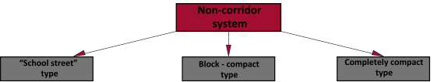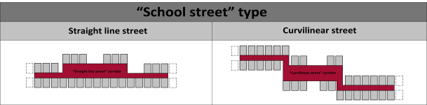

**Buildings from 19-20 century Buildings from the end of 20th and the**   
**beginning of 21th century**

Davis High School, Kaysville, USA, 2003

**With straight line “street” corridor**

Loevenich School Center, Germany, 1973

**1.2 Non-corridor system**

Non-corridor planning system may also be considered with several subtypes of derivatives.

*Fig.3. Schematic of non-corridor system subtypes*

• **“School street” type**

The name itself suggests that in this case we have a wide corridor designed, a connection

between the different areas and rooms, which interior suggests the presence of one street with all its elements: benches, lighting fixtures, façades treated differently and windows of the rooms facing it.

Table 7. Subtypes of “School street” type.

 *- “School street” type corrid or; - Classrooms*

There are two types of school buildings:

• **With “straight line street” corridor;**

• **With “curvilinear street” corridor.**

In both systems, two subsets of buildings, **symmetrical and asymmetrical,** may be distinguished**.**   
Table 8. Examples of 19-21 century “School for study” school building type

|  |  |  |
| --- | --- | --- |
| **Type of school**  **building** |  |  |
|  |  |  |
| **With curvilinear “street” corridor** |  | Graylie High School, USA 2004 |

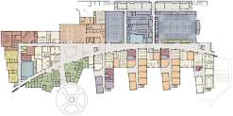

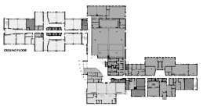

• **Block-compact type**

Solutions are characterized by a clean compact shape without excessive corridors and long

connections. The composition is formed by teaching blocks united by a central block.

**Joint**   
**connection blocks**

Halfield School, UK 2001-05

Table 9. Subtypes of block-compact type.

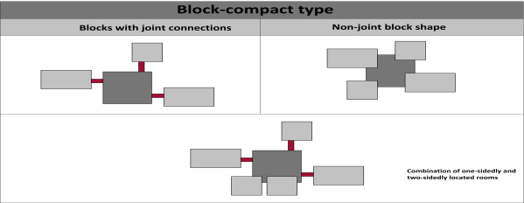

• **Subtype where the blocks are connected to the central block by joints** – in this example, the additional bodies of the school building are connected to the main body through joints that are corridors or foyers.

• **Subtype where the blocks are pointlessly connected** – in this method of school building planning there is again individual zoning but the connection is constructed through the interconnection of common premises

• **Subtype – combination of joint and non-joint block connections** – all the advantages of the first two subtypes may be used and realized on a smaller area of the plot.

Two subtypes of buildings may be considered for each of the above three systems: **symmetrical and asymmetrical**.

Table 10. Examples of 19-21 century “School for study” school building type

|  |  |  |
| --- | --- | --- |
| **Type**  **school**  **building** |  |  |
|  |  |  |
| **Non-joint connection blocks** | School Center, Austria, 1973 | School in Vantaa, Finland |

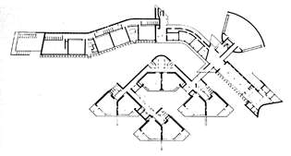

• **Completely compact type**

With this type of planning, closed spaces are achieved, relying mainly on an indoor closed

climate, which is achieved by technical means. It is characterized by a space gradation, a relaxed interior and mobility of partition elements.

**Buildings from 19-20 century Buildings from the end of 20th and**   
**the beginning of 21th century**

**Buildings from 19-20**

**Buildings from the end of 20th**   
**and the beginning of 21th century**

**century**

Primary School in   
Vesteroi, Norway, 1968

**Central**   
**single block**

St Ambrose School, Wicker, UK

Table 11. Subtypes of completely compact type.

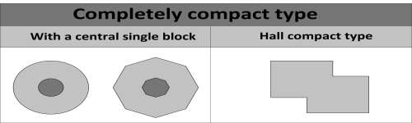

• **Central single block** – used in schools with fewer students, mostly of the same age group.

• **Hall compact type –** the open hall spaces are “blind” – the periphery is closed, it is relied

on the internal working climate achieved by technical means.

Plan non-corridor compactness may be achieved in two ways: through wide-area blocks and

full-height compactness.

Table 12. Examples of completely compact type of 19-21 century school buildings

|  |  |  |
| --- | --- | --- |
| **Type of**  **school building** |  |  |
|  |  |  |
| **Hall**  **compact type** | Wörner Rieden School in  Malmö, Sweden, 1970 | Elementary School, Boston, USA |

In the end, no matter which type of school building you choose when planning, the goal is to achieve a good, functional space for interior development, to achieve a good learning environment with maximum comfort and light loads on students and teachers.

From the architectural point of view, it is particularly important to move from a corridor to a compact structure. The use of the interior space of the wide-area blocks favors the formation of “interior density” and allows the modeling of the interior. This transition permanently removes any controversial conventions in the orientation of the premises to the world directions, and the classes may be held in the most appropriate room at that point. In this planning system, it is most important to overflow the spaces in one another, the possibility of increasing the size of the premises by means of mobile partitions for the needs of the learning process. Planning compactness and interior attractiveness are the key issues for solving both the energy problem and the ergonomic learning environment.

**Conclusions.**

• Area buildings should match the number of students, type of training, grades and number of classes.   
• Buildings should include spacious rooms with good sunlight and good ventilation.

• Buildings should be energy-efficient.

• The design of the buildings should be tailored to the plot on which they will be built, as well as to the geographic directions.

• During the planning, studies of people flows should be carried out in order to determine the best entry points for visitors, students, parents, staff and business purposes.

• The connections between the premises must be clear, concise and functional.

**REFERENCES**

1. “Pediatric and pedagogical psychology”, G.D. Pirgov, St. Zhelev

2. „The Language Of School Delight – Design Patterns for 21st Century Schools”, Prakash Nair & Randall   
Fielding, 2005;

3. “Toward Better School Design”, William W. Caudill,1954;

4. “School Architecture: Design for Elementary and Secondary Schools”, 2005;

5. “Architectural Design”, Ernst Neufert,

6. “Color Psychology in Interior – The Language of Colors in 21st Century Interior Decorations”

13. <http://www.booktraffic.bg/userfiles/Fundamentalna_teoria_na_cvetovete_booktraffic_istok_zapad.pdf>

14. <http://www.utiledesign.com/projects/mattahunt-elementary-school/>

15. <http://www.designshare.com/index.php/projects/adharshila-vatika/images@5039>

16. <http://www.thearchitectureofearlychildhood.com/2011/09/european-school-design-types-for-21st.html>

19. <http://www.itlearning-bg.com/magazines/Spisanie2013/resources/>

20. <http://www.ncef.org/pubs/greenschoolshistory.pdf>

21. <http://zainteriora.com/2012/01/11/creative-school-house/>

22. <http://www.dezeen.com/2011/05/23/josephine-baker-schools-by-dominique-coulon-associes/>

23. <http://www.dezeen.com/2013/11/10/secondary-school-ergolding-by-behnisch-architekten/>

24. <http://socialevo.net/teoriya-na-cvetovete-v-ueb-dizayna-429447>

25. <http://www.karenwalstraconsulting.com/home/index.php?ipkArticleID=43>

26. <http://www.wbdg.org/design/elementary.php>

27. <http://www.publicarchitecture.co.uk/knowledge-base/files/Design_of_sustainable_schools_case_studies.pdf>